**Creating Resource Group:**

**East US RG:**

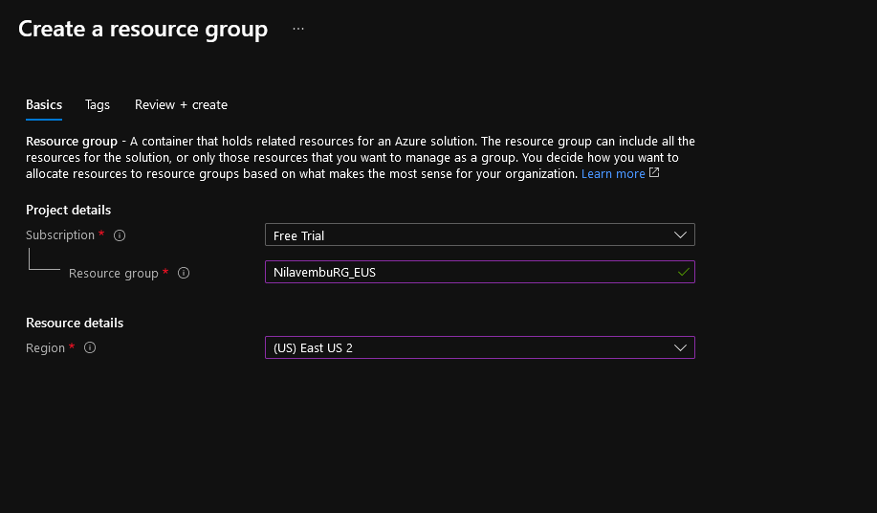

**SEA RG:**

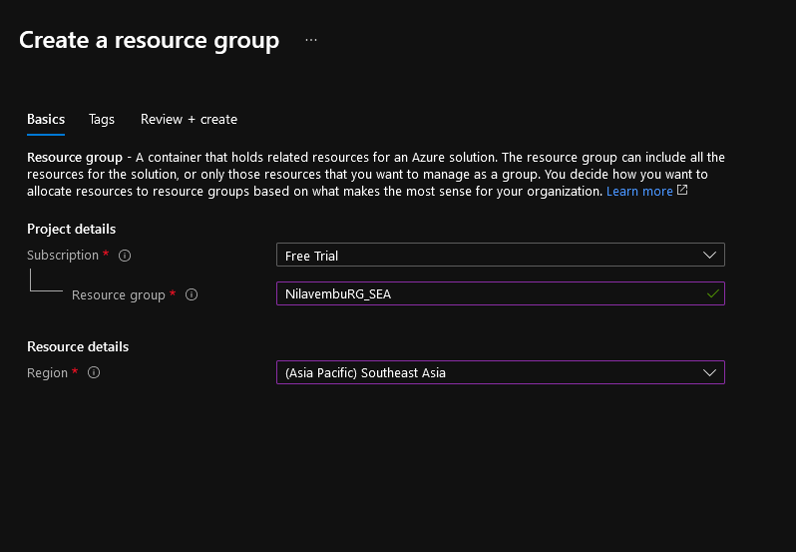

**Vnet Creation:**

**Vnet-Eu:**

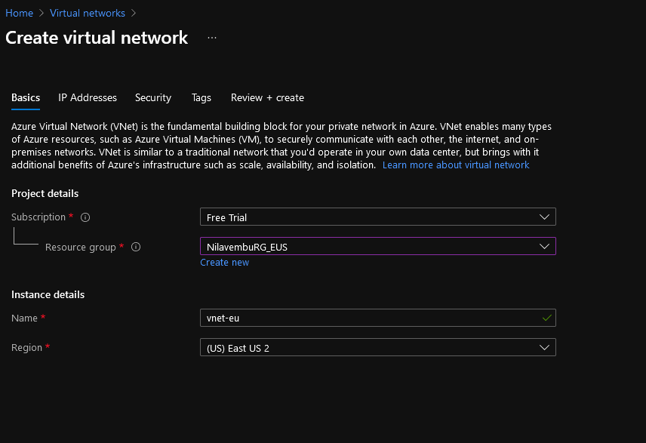

**Subnet Creation and IP:**

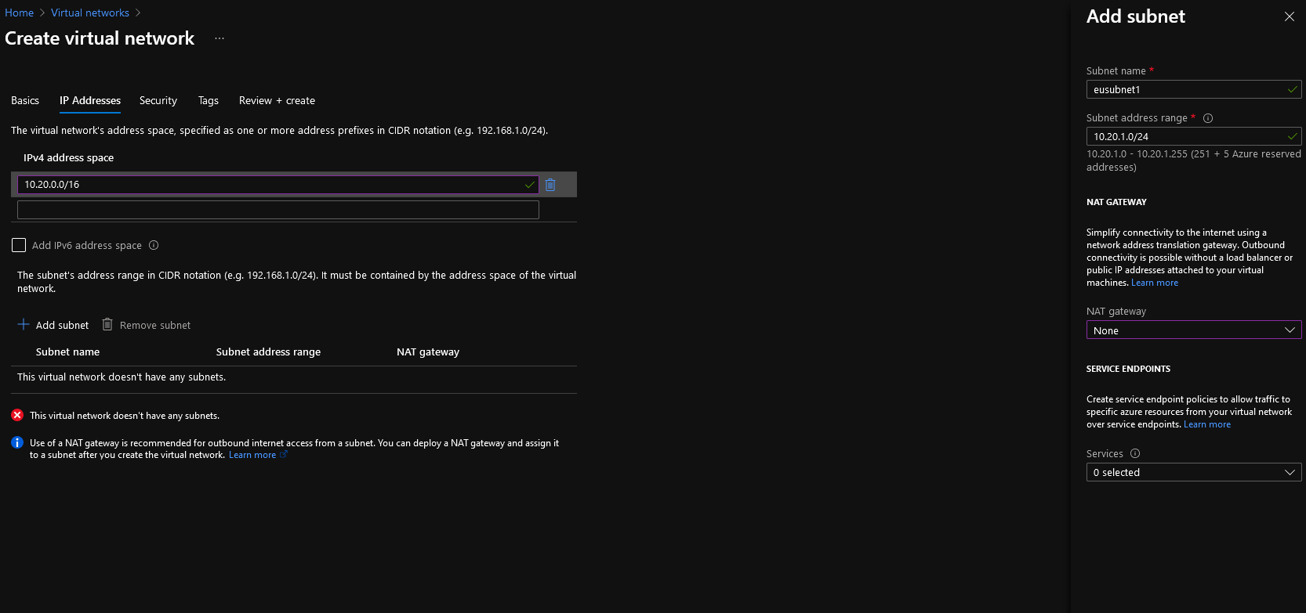

**SEA Vnet Creation and Subnet:**

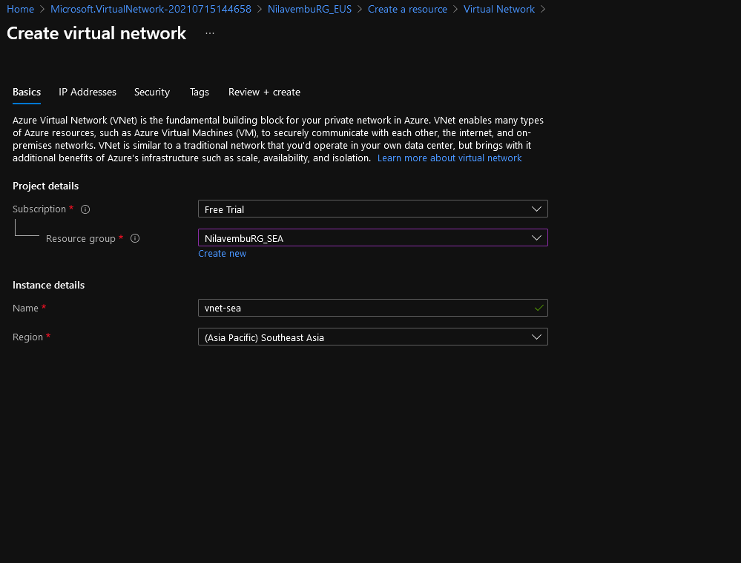

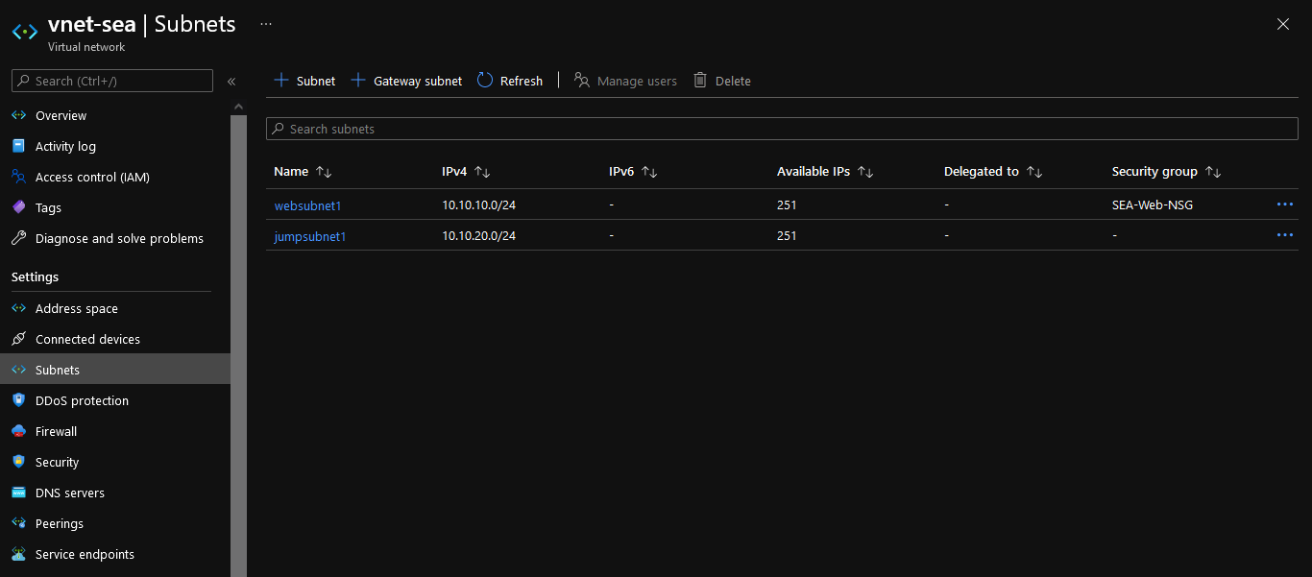

**NSG Creation and rules:**

**EUS:**

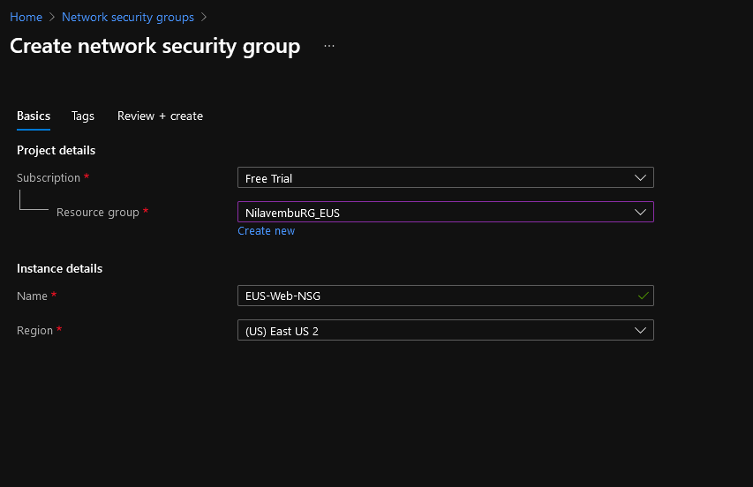

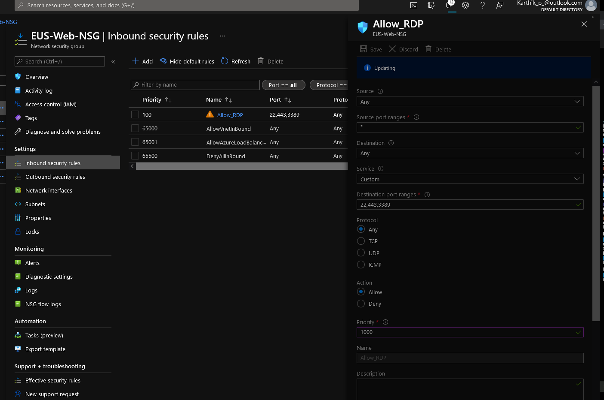

**Associating to the eusubnet1:**

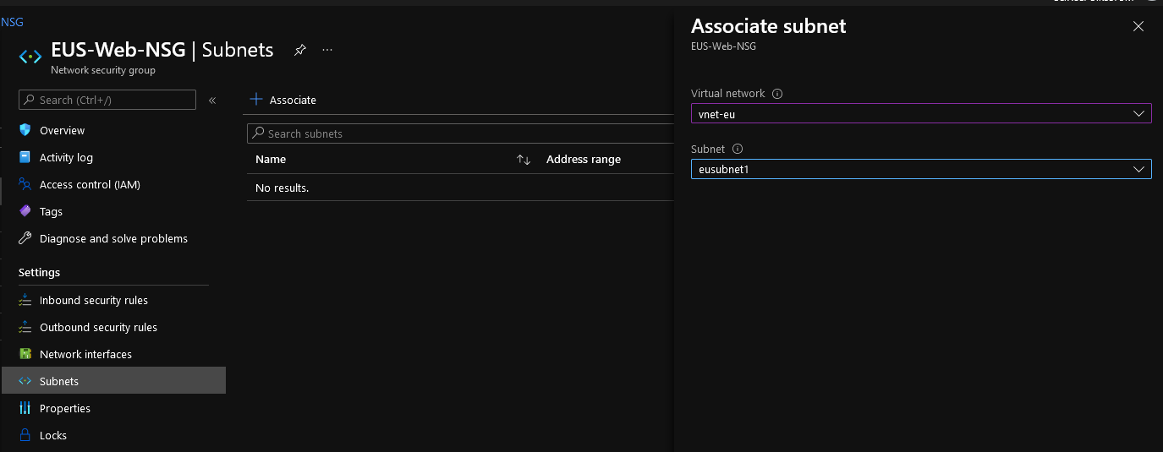

**SEA:**

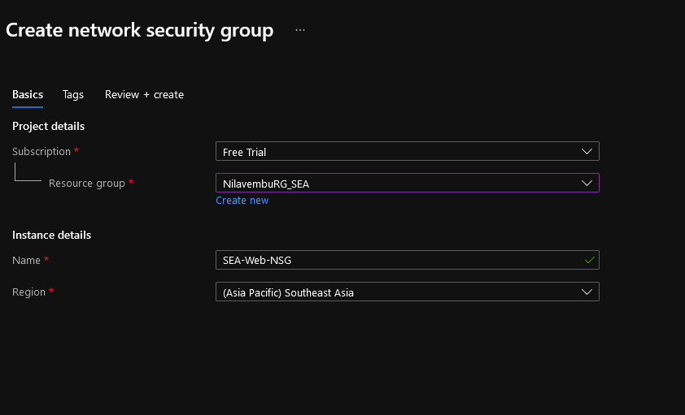

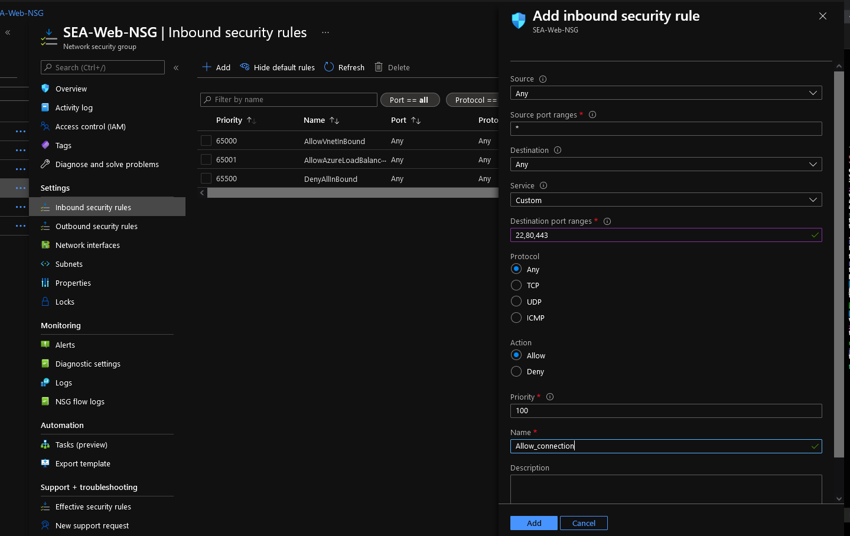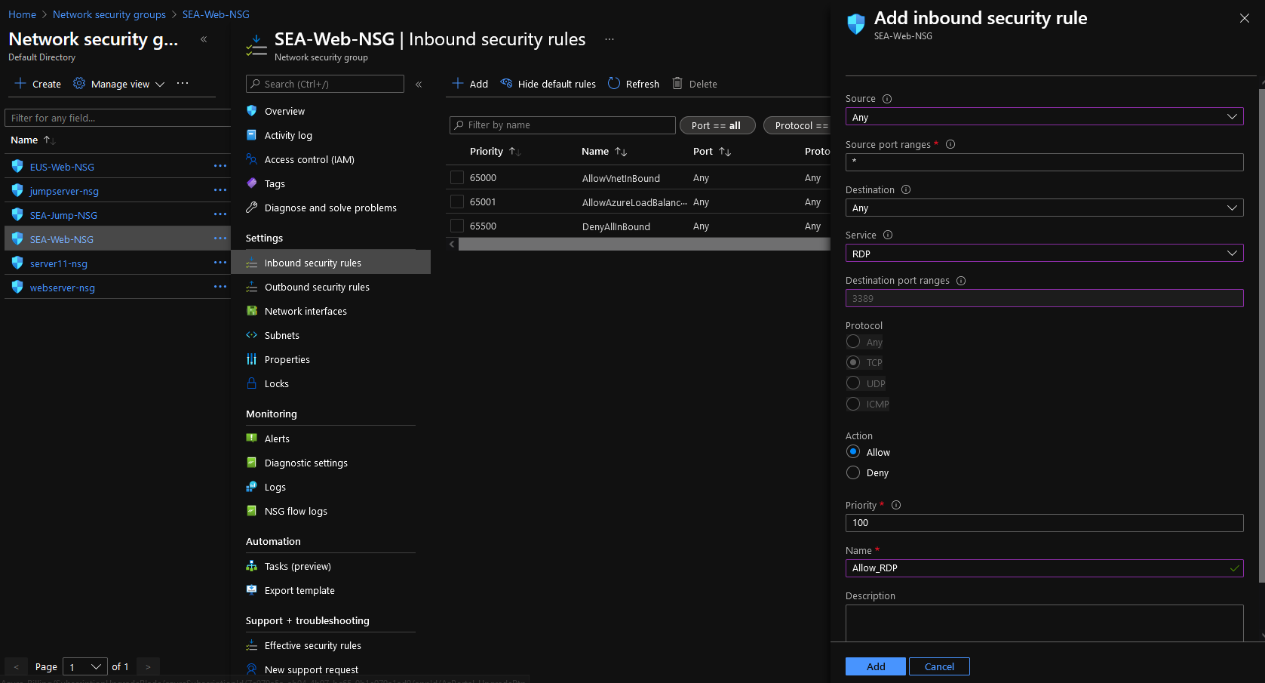

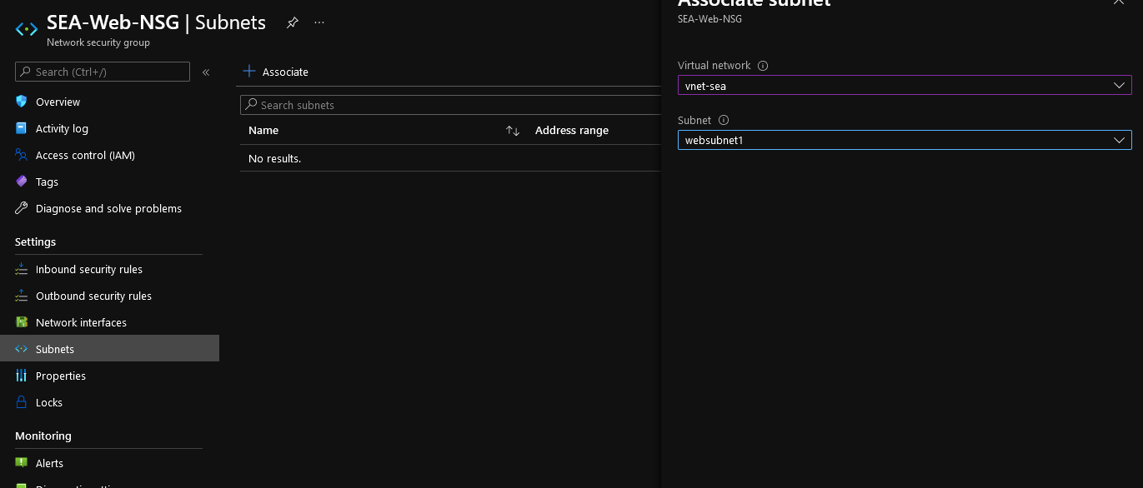

**SEA Jump NSG:**

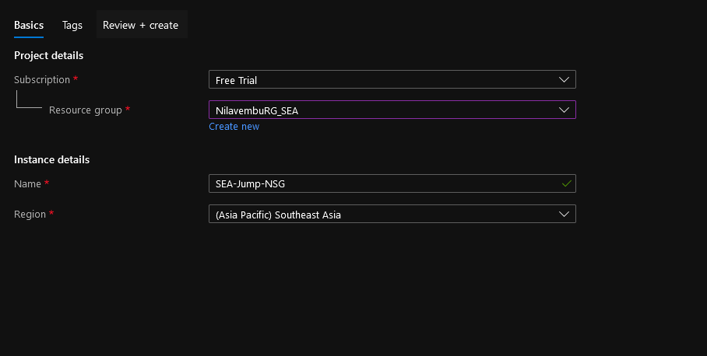

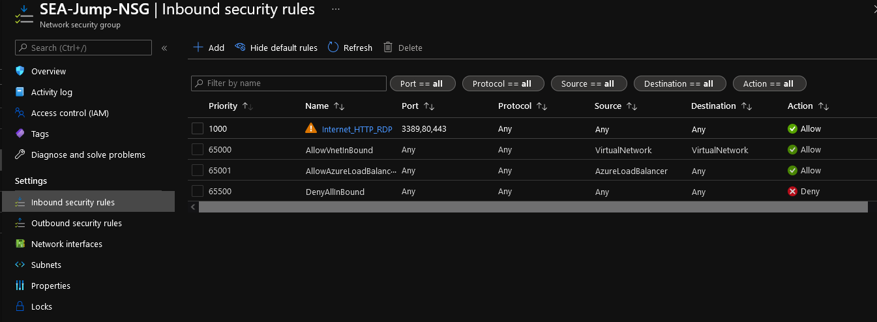

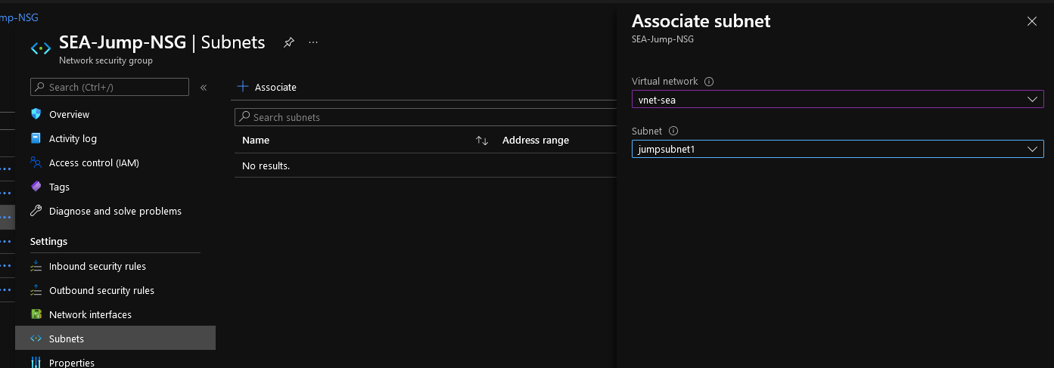

**Creating Availability Set:**

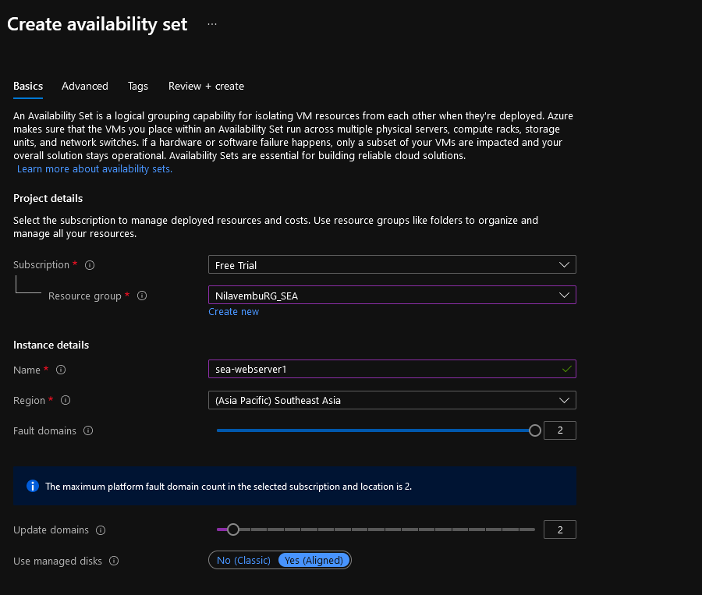

**Creating VM’s:**

**SEA:**

**Webserver1:**

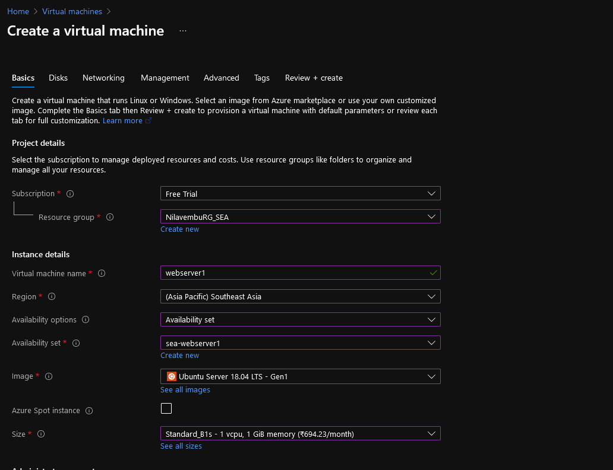

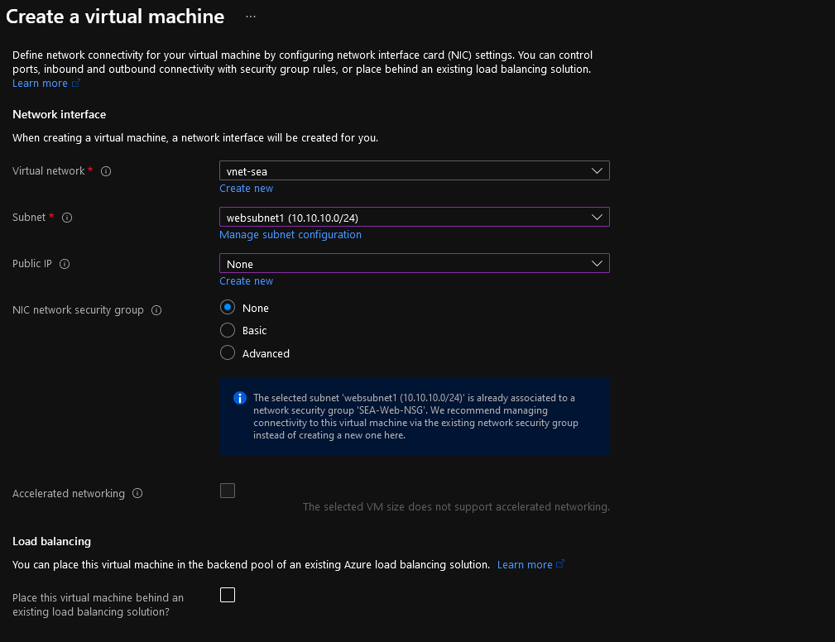

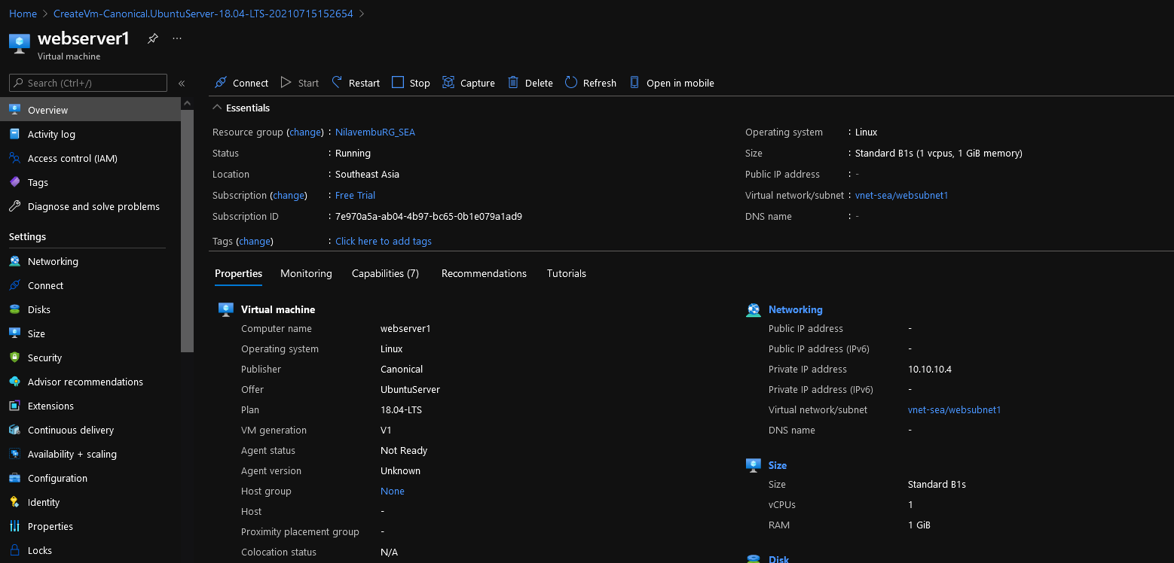

**Webserver2:**

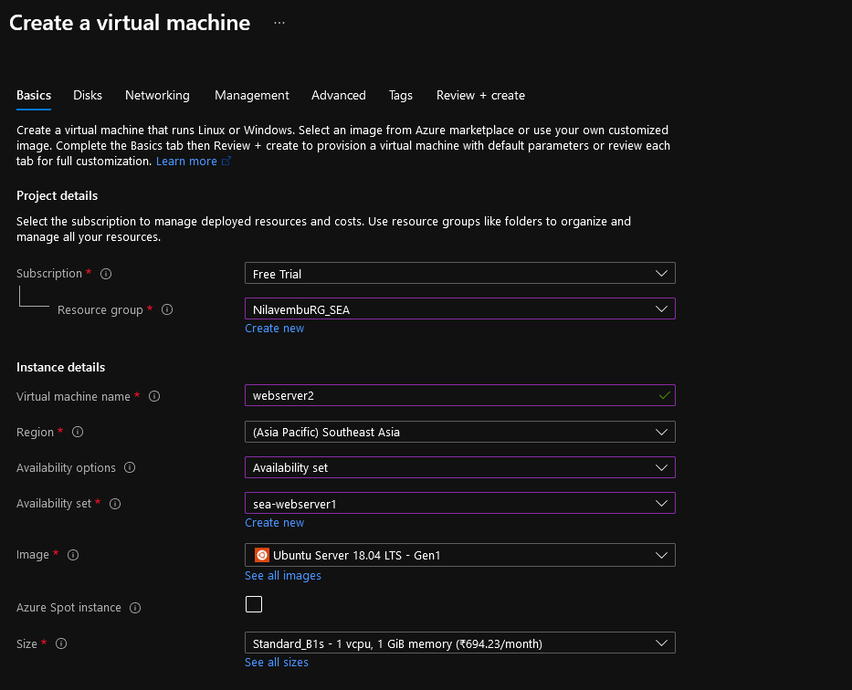

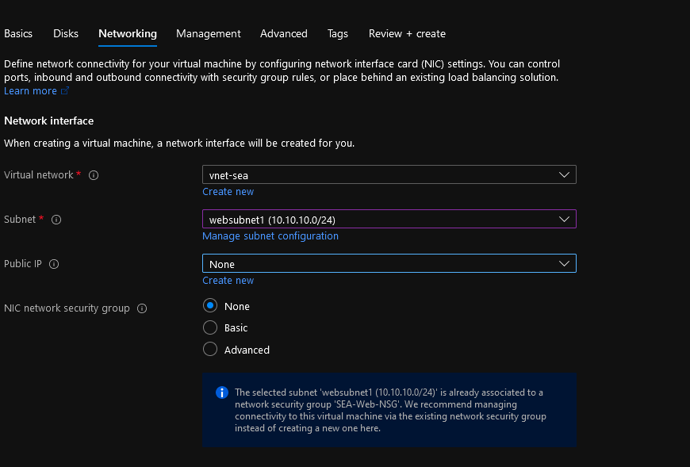

**Jump Host:**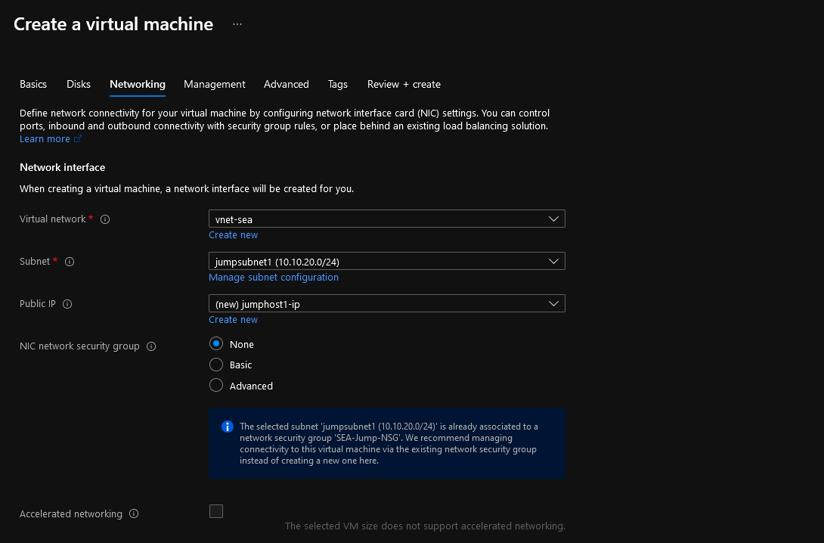

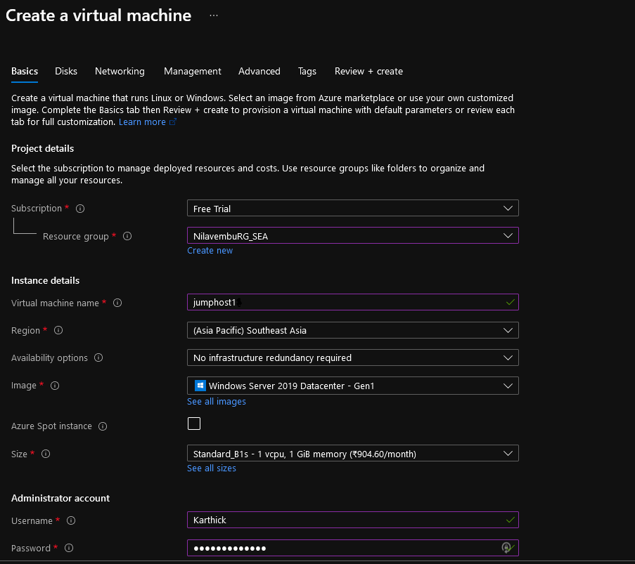

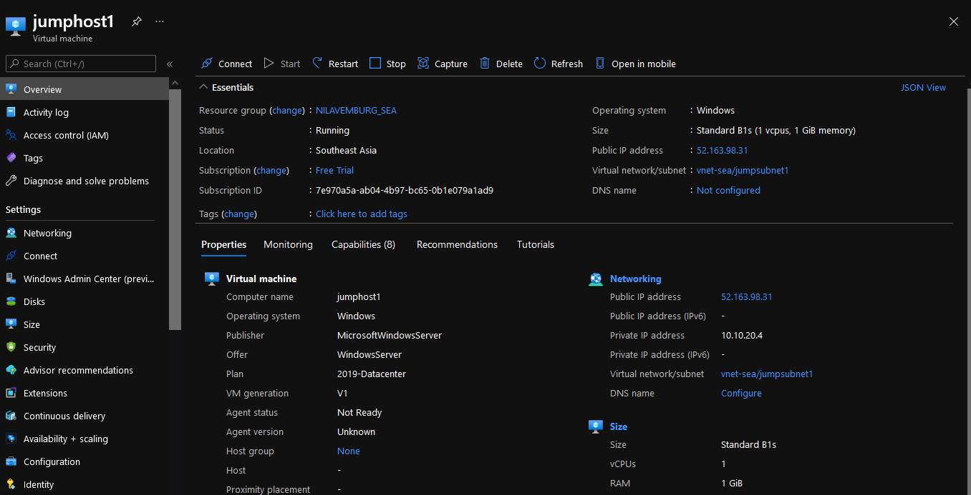

**EUS:**

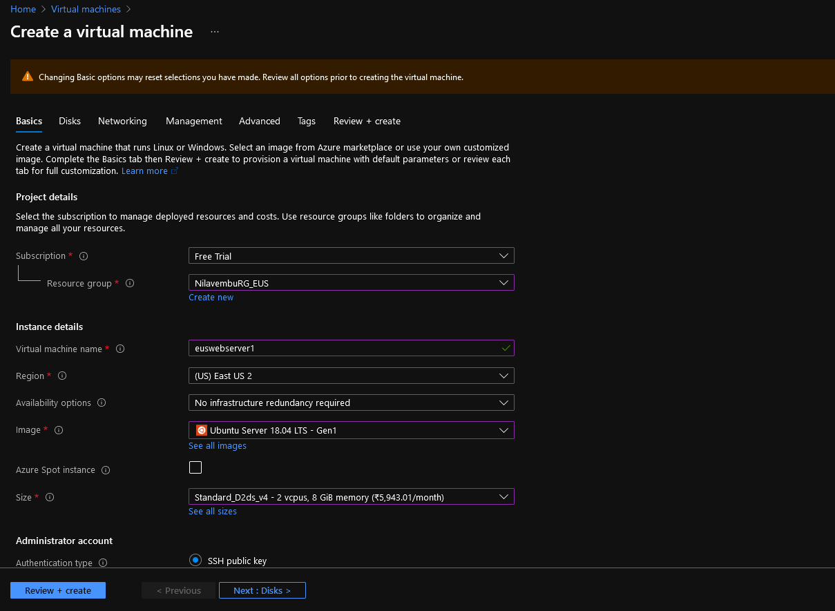

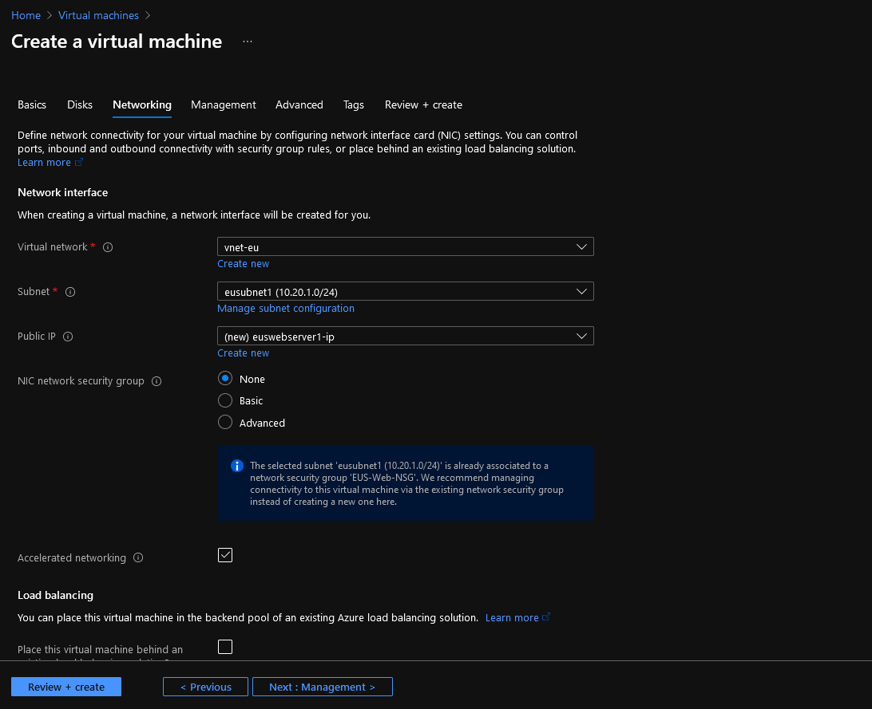

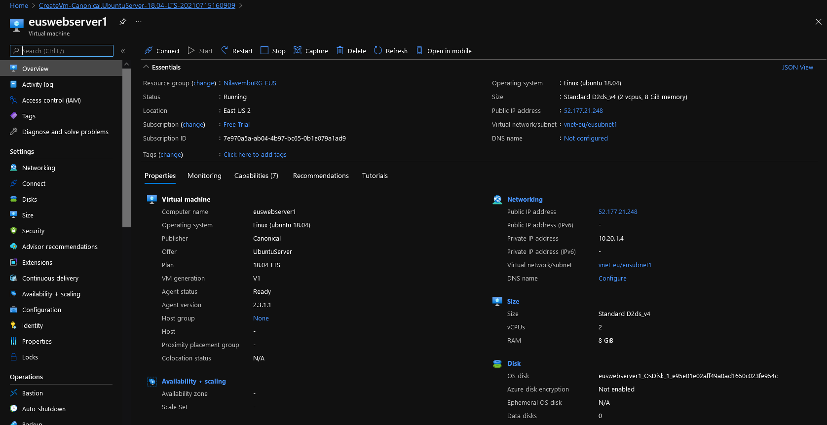

**Load Balancer with Frontend Public IP:**

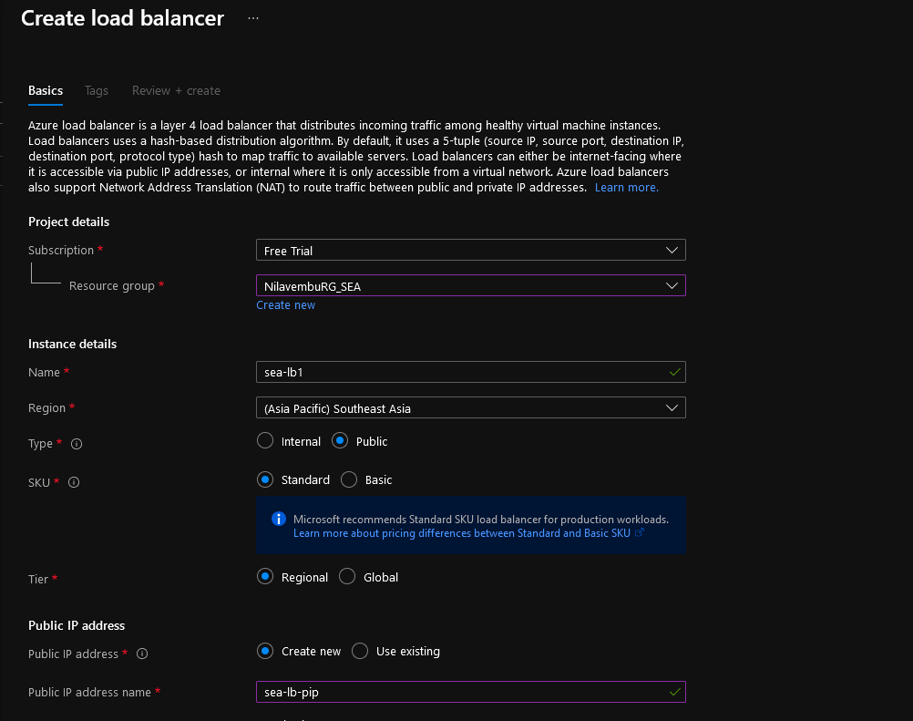

**Backend Pool:**

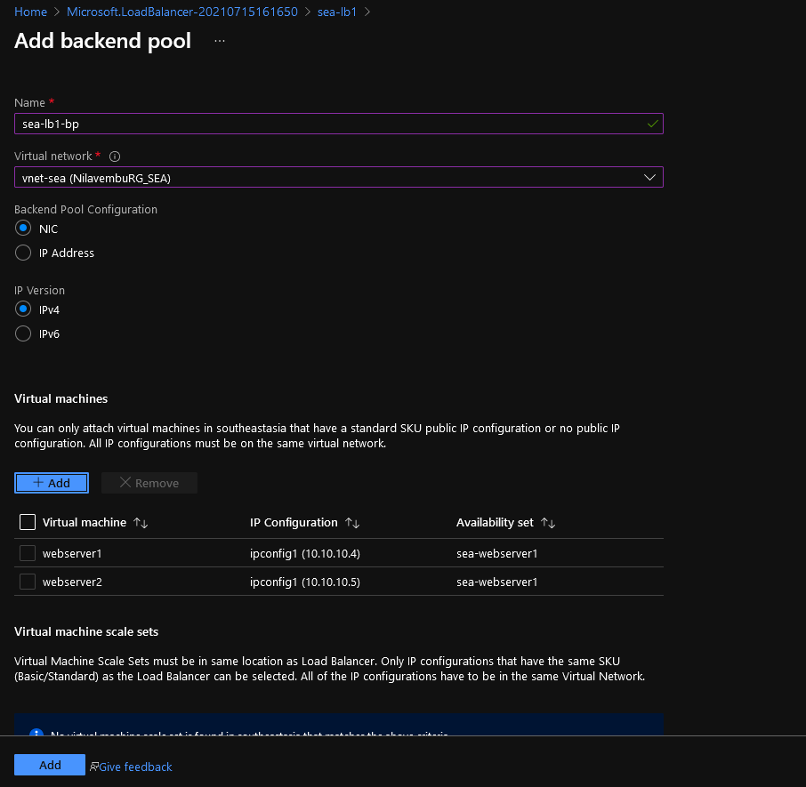

**Rule:**

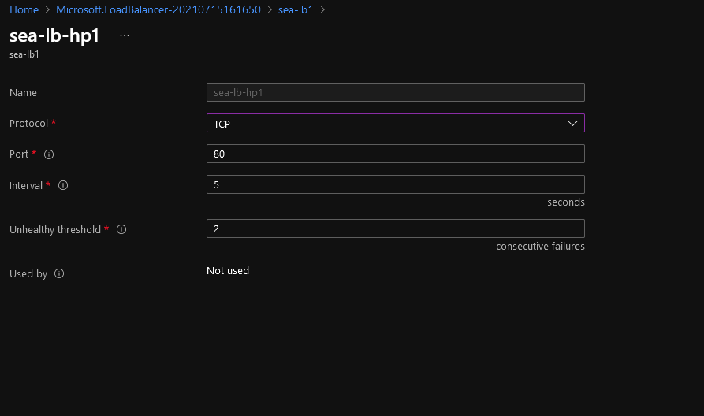

**Creating Outbound Rule cause Webserver is unable to connect to Ubuntu servers:**

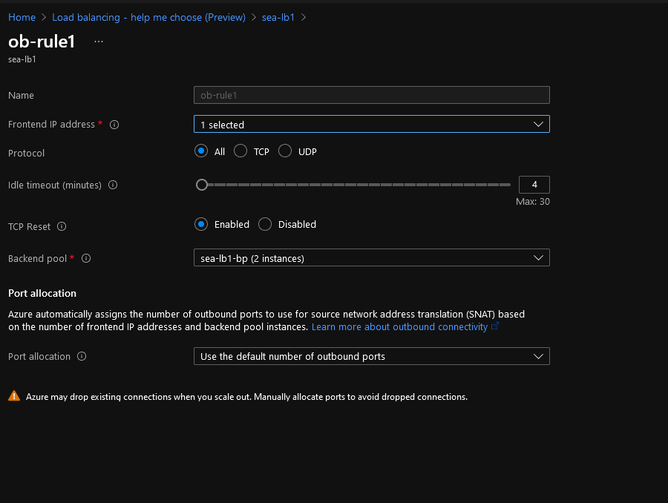

**Inbound NAT:**

**Webserver1:**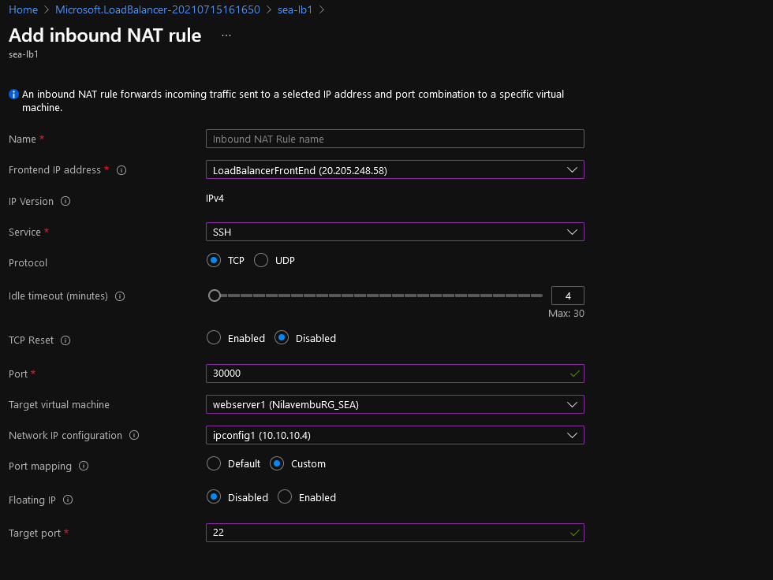

**Webserver2:**

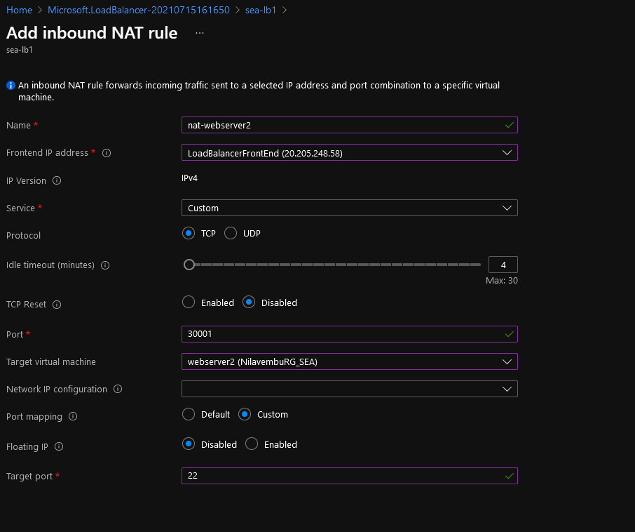

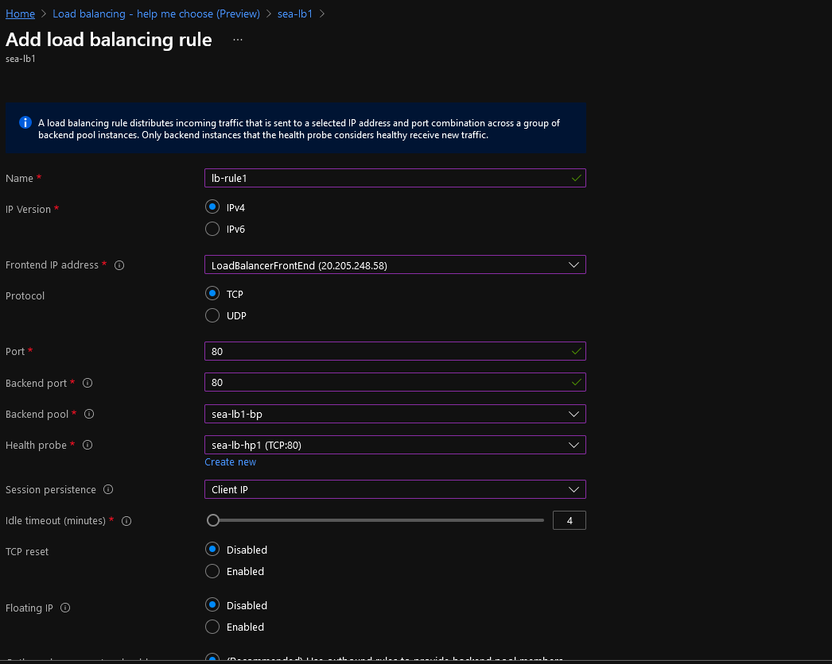

**Created a script to install Apache and add the necessary info for the webserver:**

**Shell.sh:**

**sudo apt-get update**

**sudo apt-get -y install apache2**

**sudo service apache2 start**

**sudo rm /var/www/html/index.html**

**sudo echo "<html>**

**<head>**

**<title> Nilavembu Herbs </title>**

**</head>**

**<body>**

**<p> I'm running this Nilabembu Herbs Website on SEA web server1!**

**</body>**

**</html>" | sudo tee -a /var/www/html/index.html**

**Connecting to SEA Webserver1 using karthick@ip(Port:30000)**

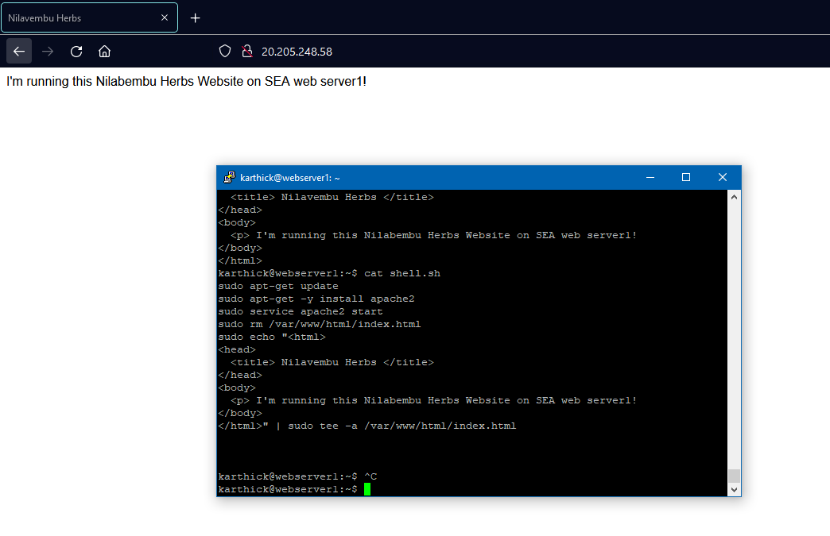

**Connecting to SEA Webserver2 using karthick@ip(Port:30001)**

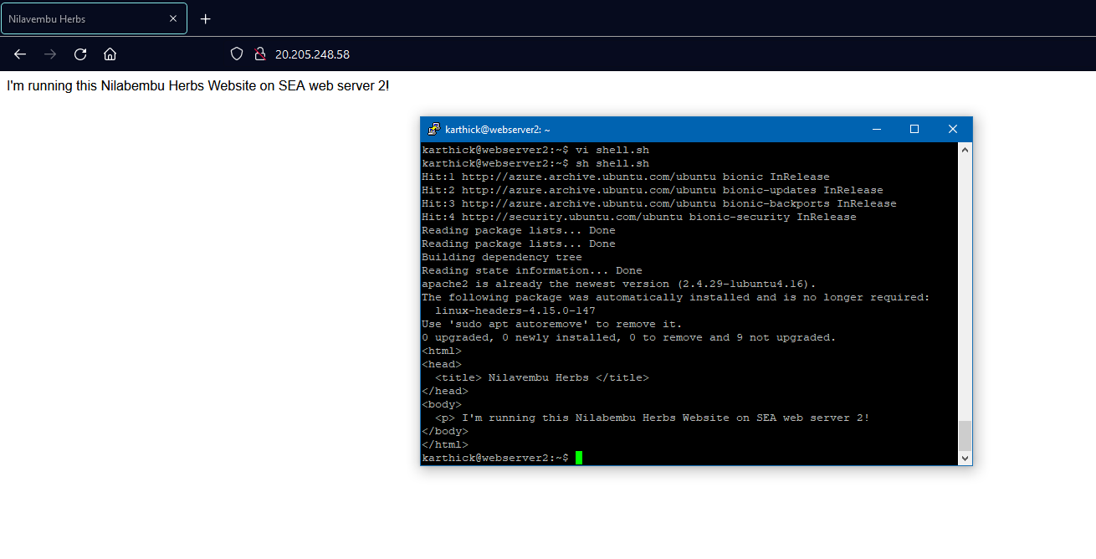

**EUS Webserver:**

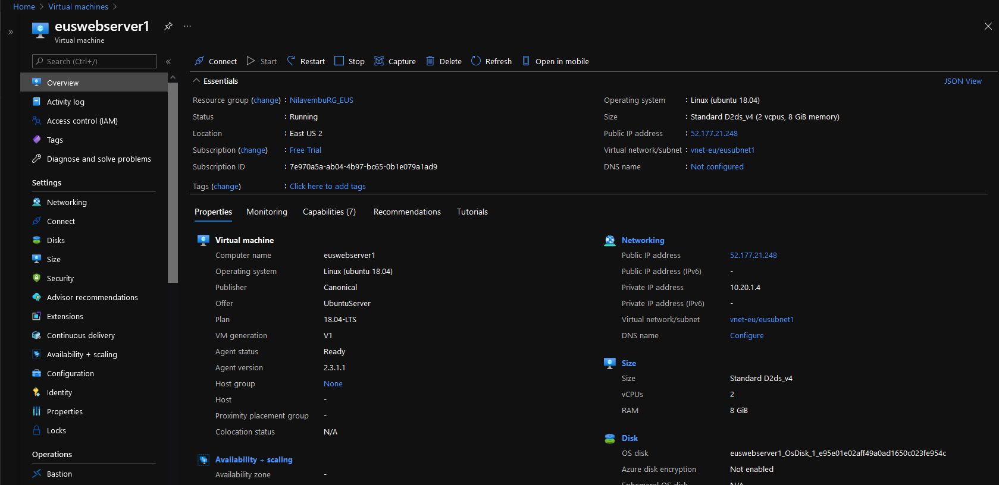

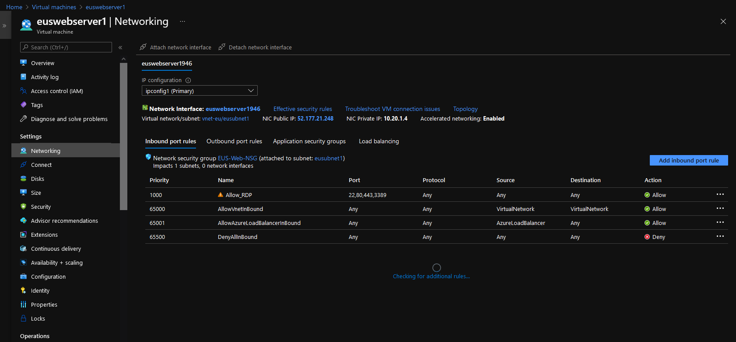

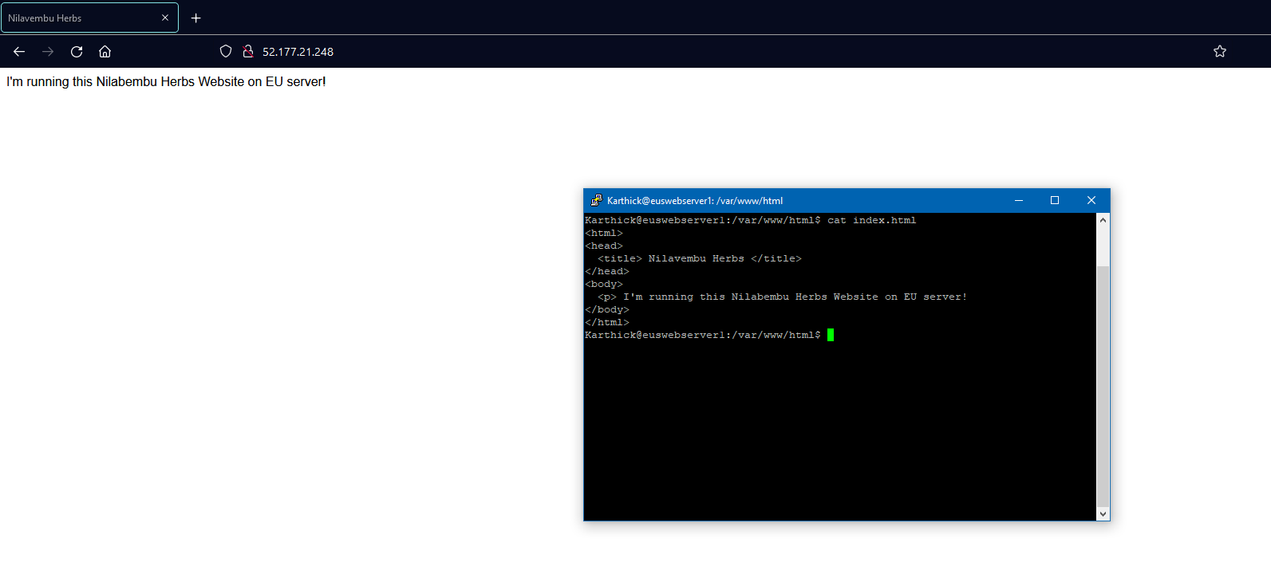

**Connected to Jump Server and accessing the webservers:**

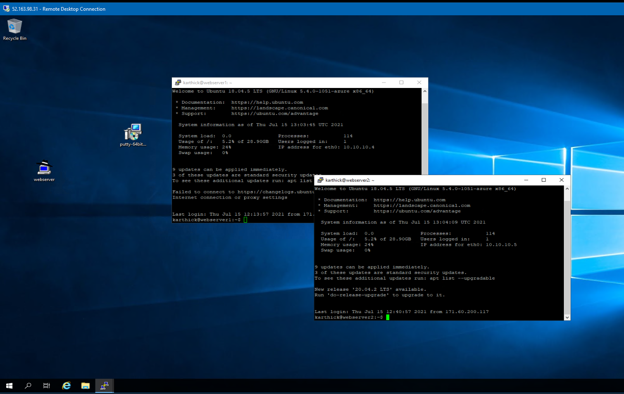

**Changing NSG to allow traffic only from selected IP Addresses:**

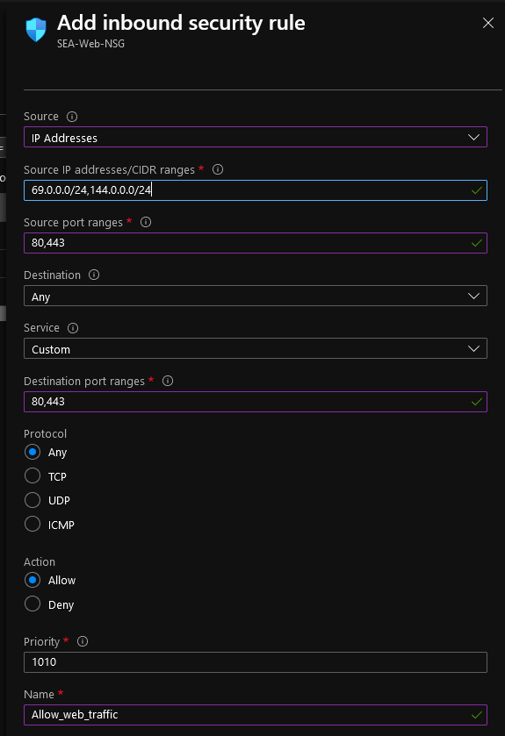

**Alerts:**

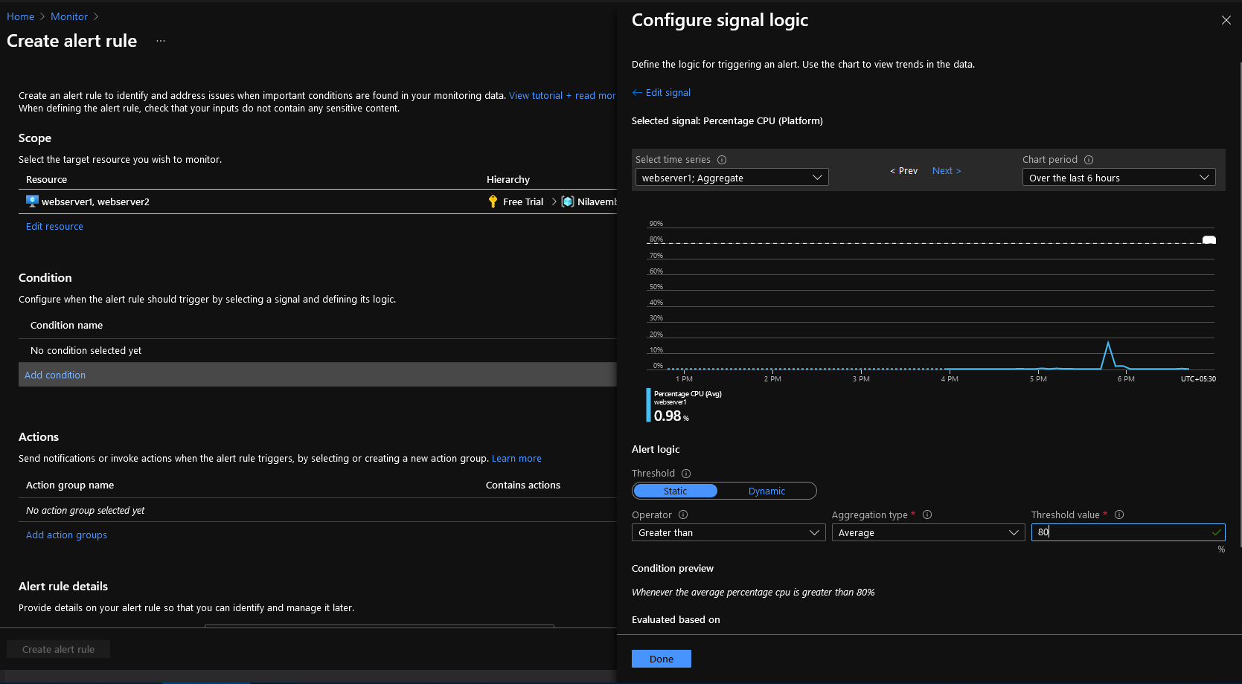

**Action Group:**

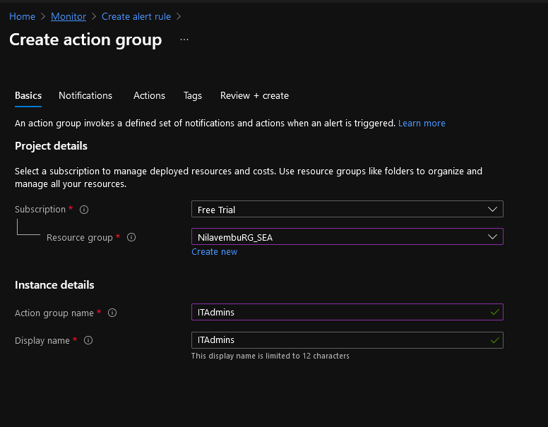

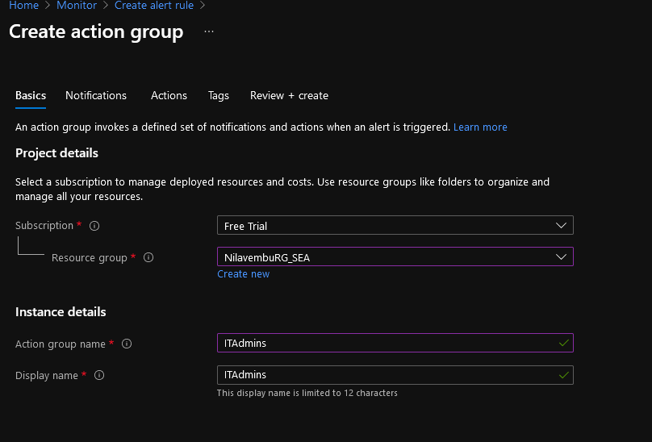

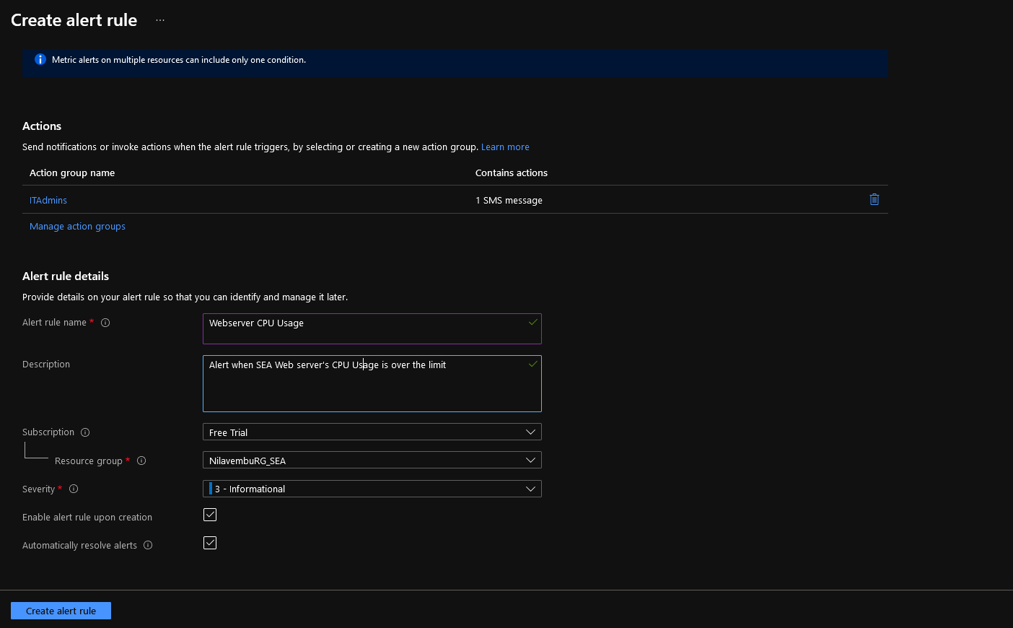

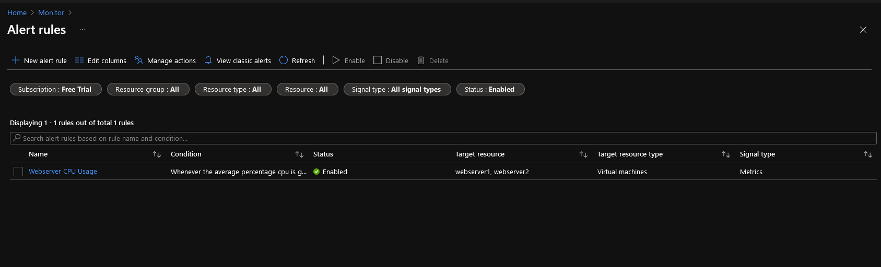

**Creating BackupVault:**

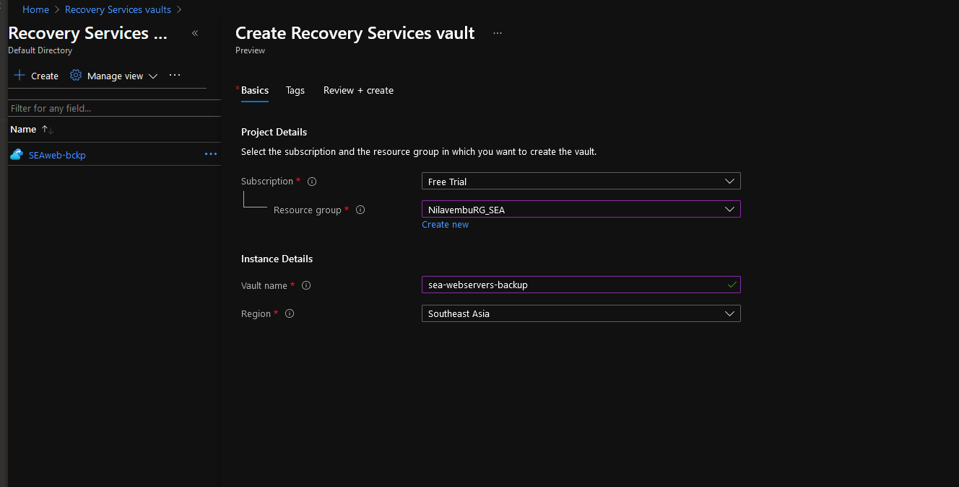

**Backup policy:** 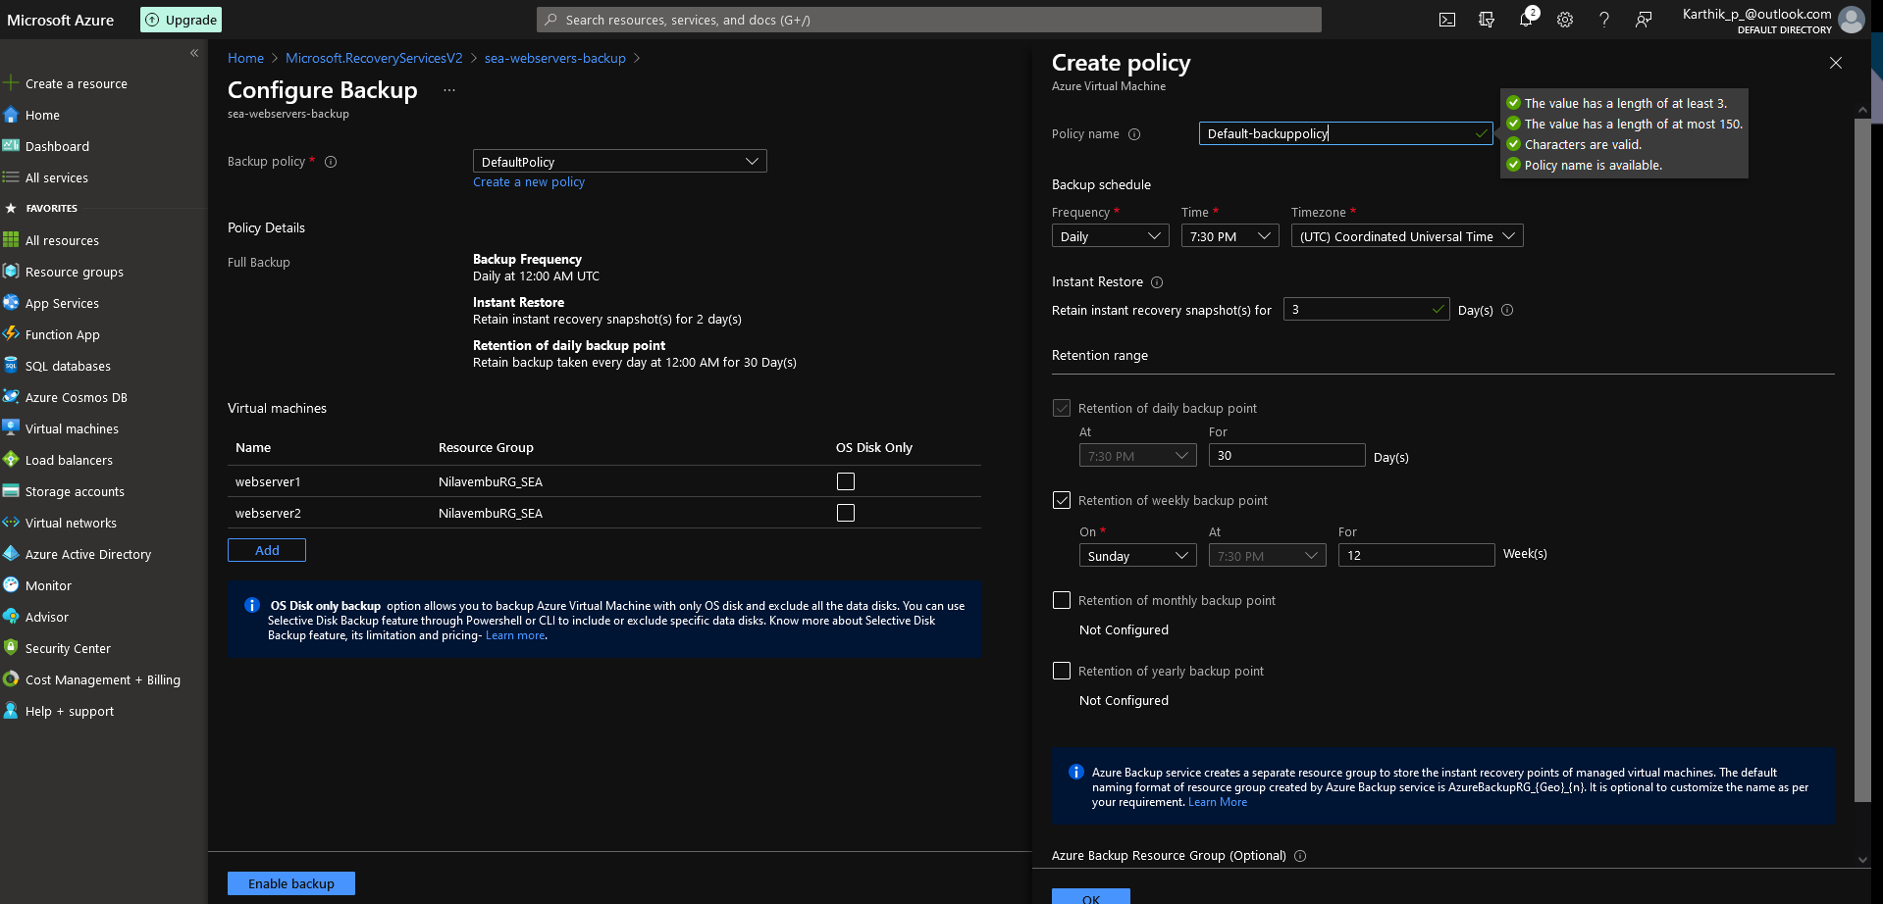

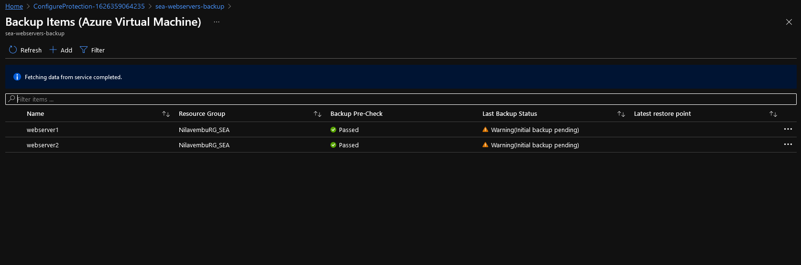

**Vnet Peering:**

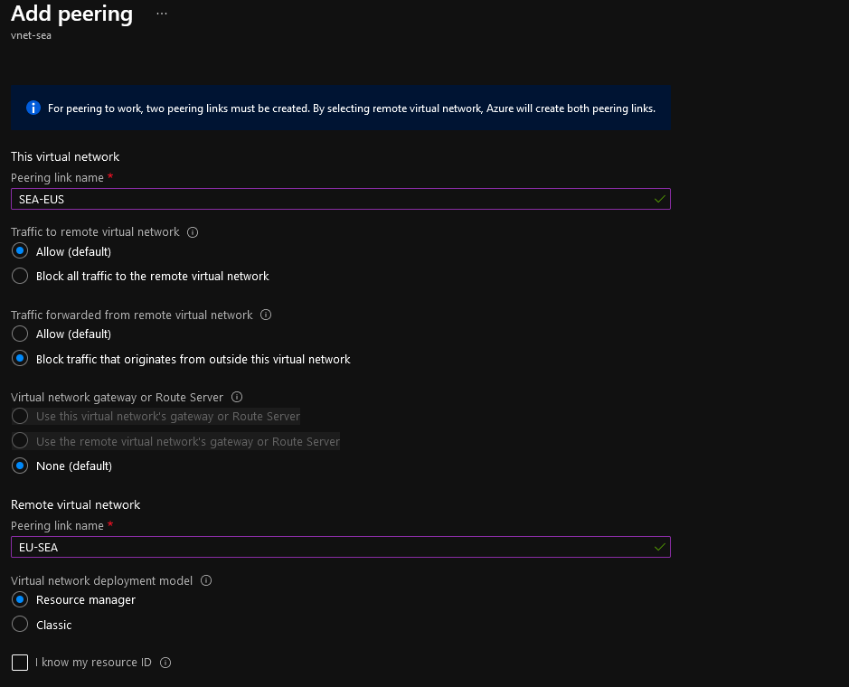

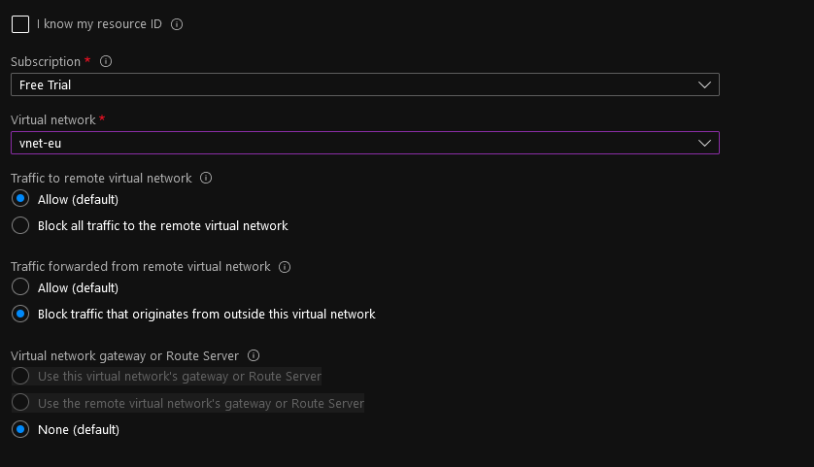

**Connected from Jumphost(vnet-sea) to EUwebserver1(vnet-eu) and from EUwebserver to webserver1 located on vnet1:**

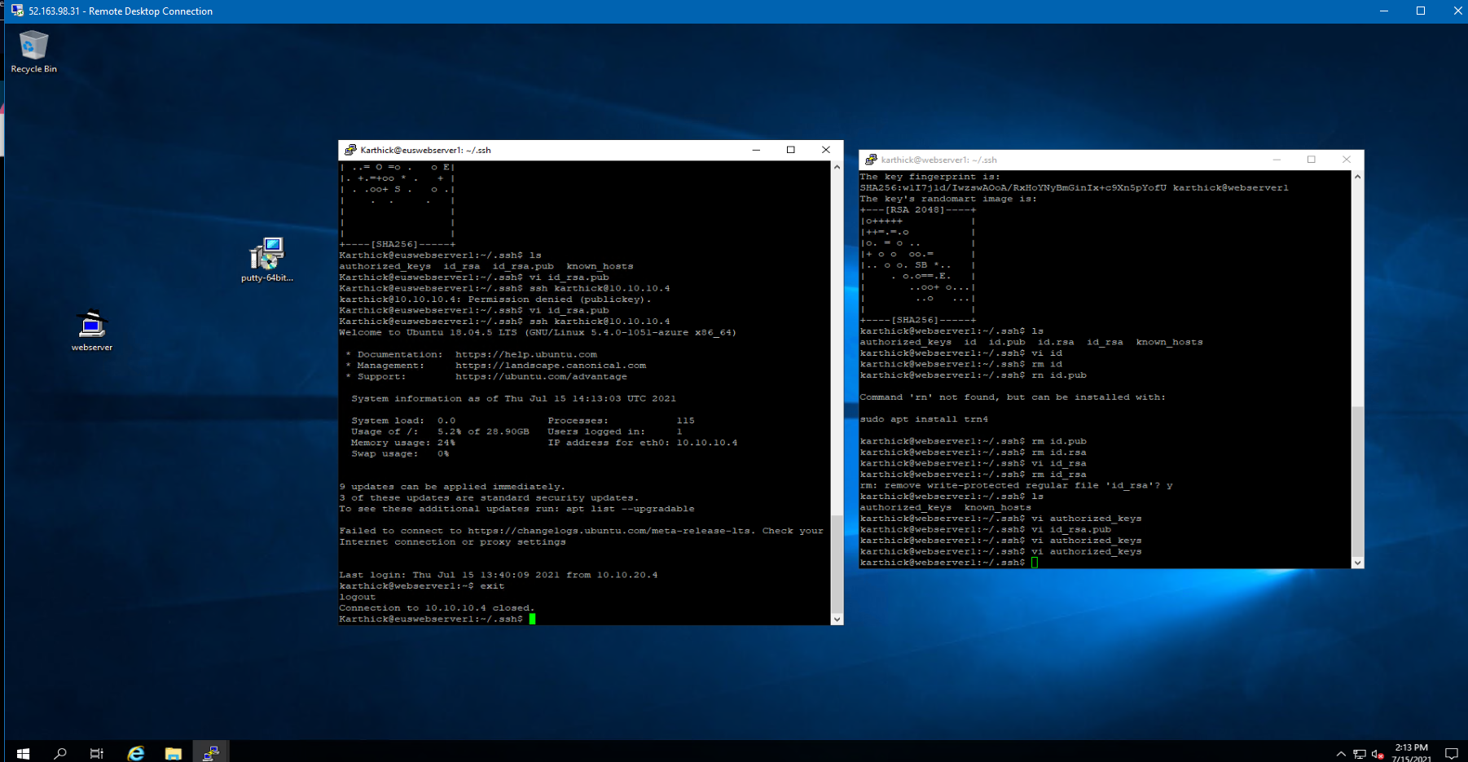

**Storage account:**

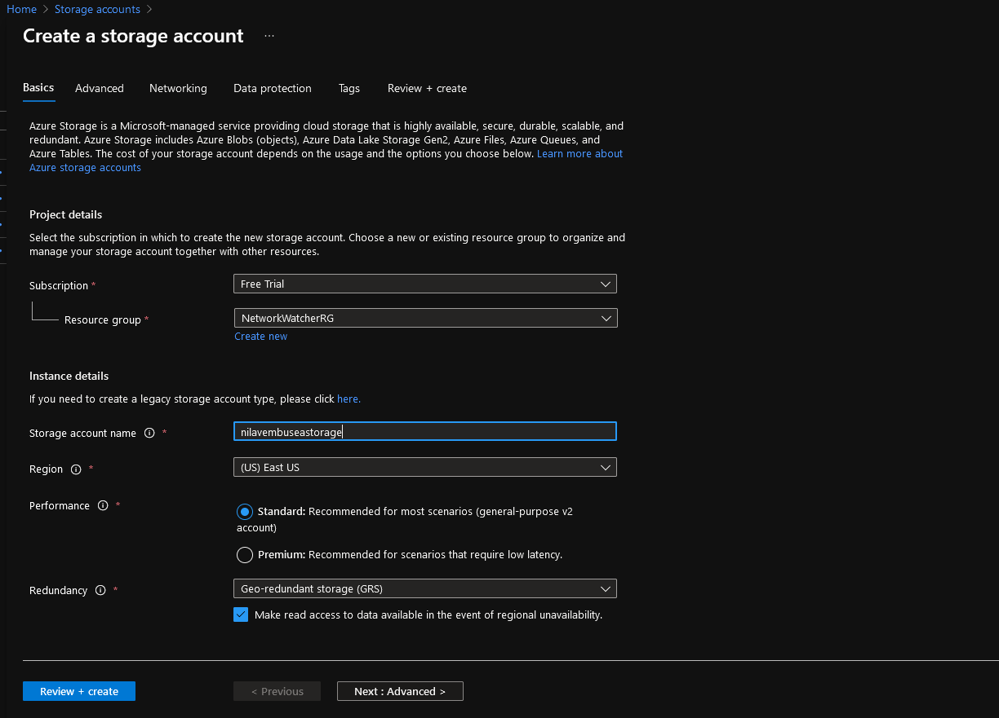

**EU Storage:**

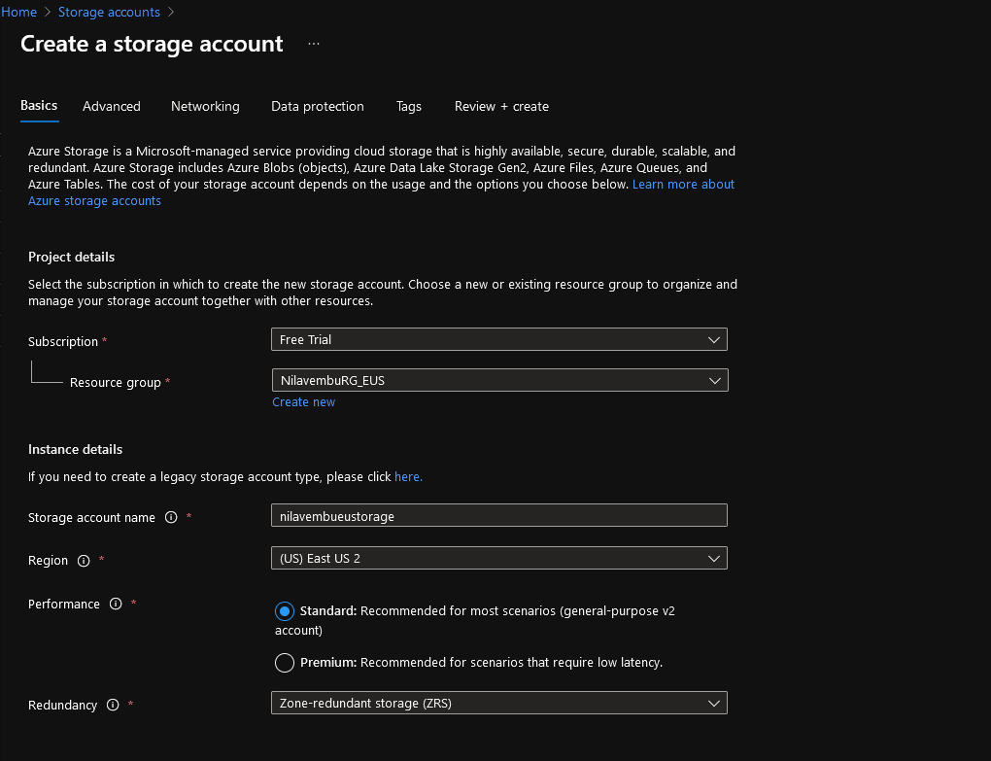

**EU Storage File share accessible Windows File Explorer for Sales manager:**

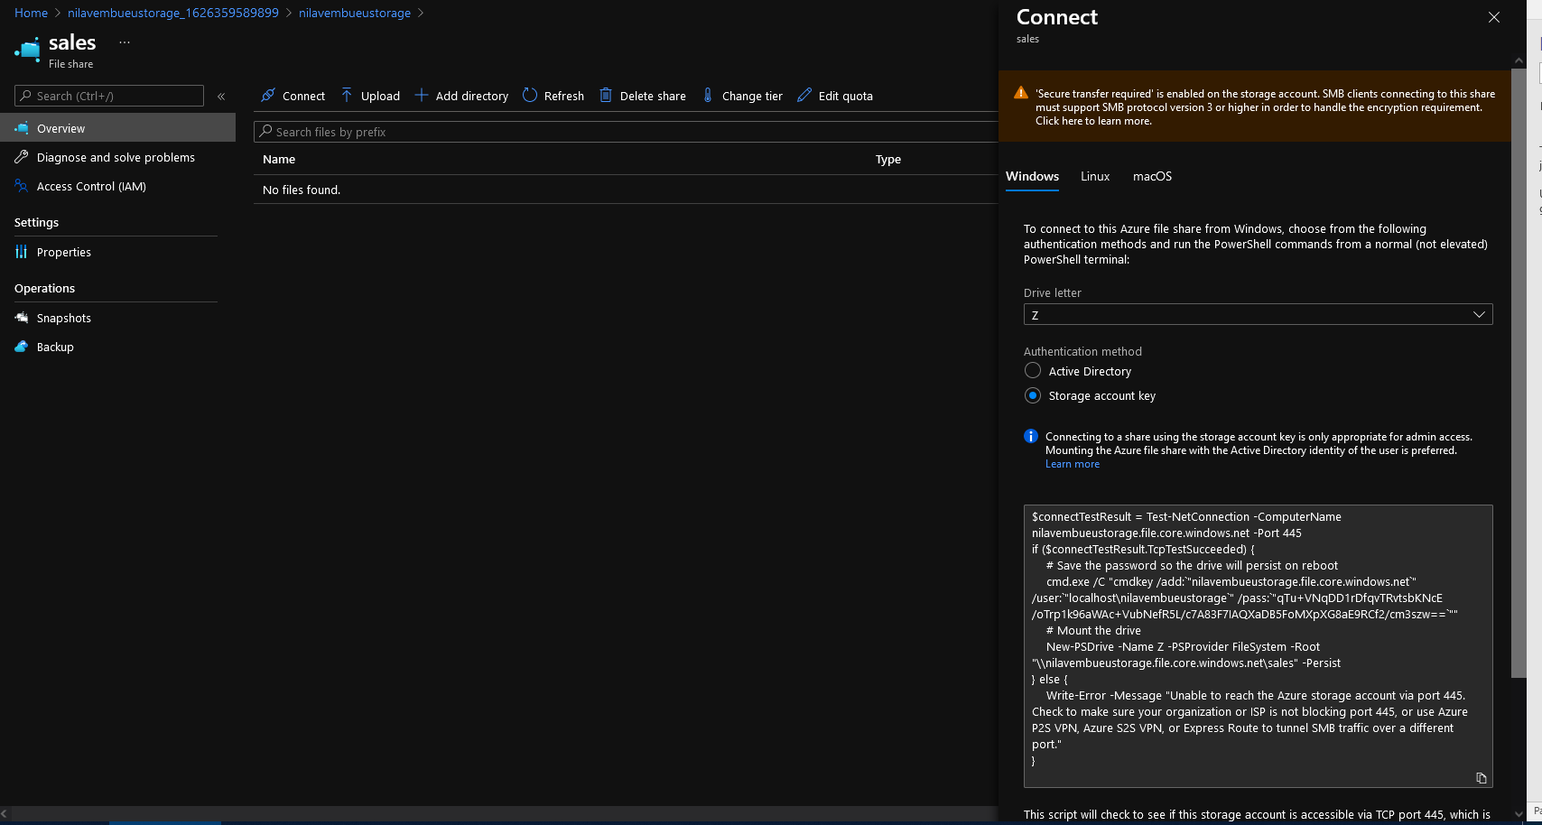

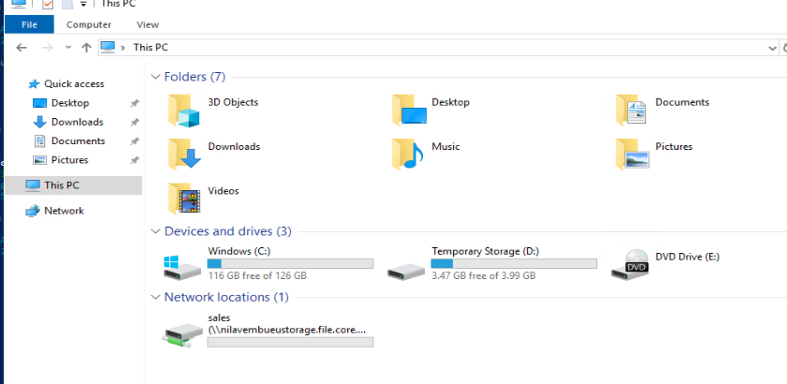

**Secure Access with SAS token with URL(can be configured):**

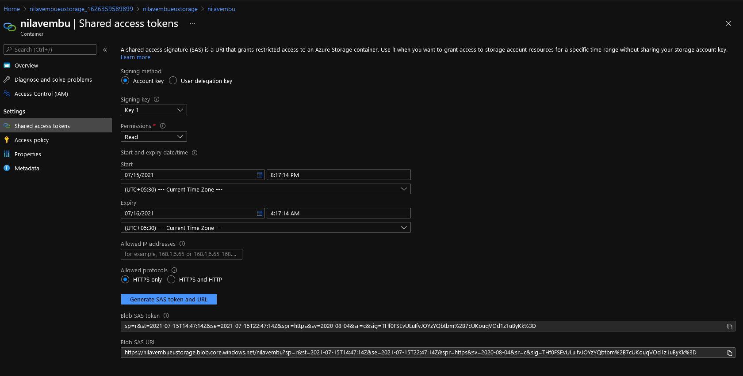

**Users VMAdmin and Backup_admin created:**

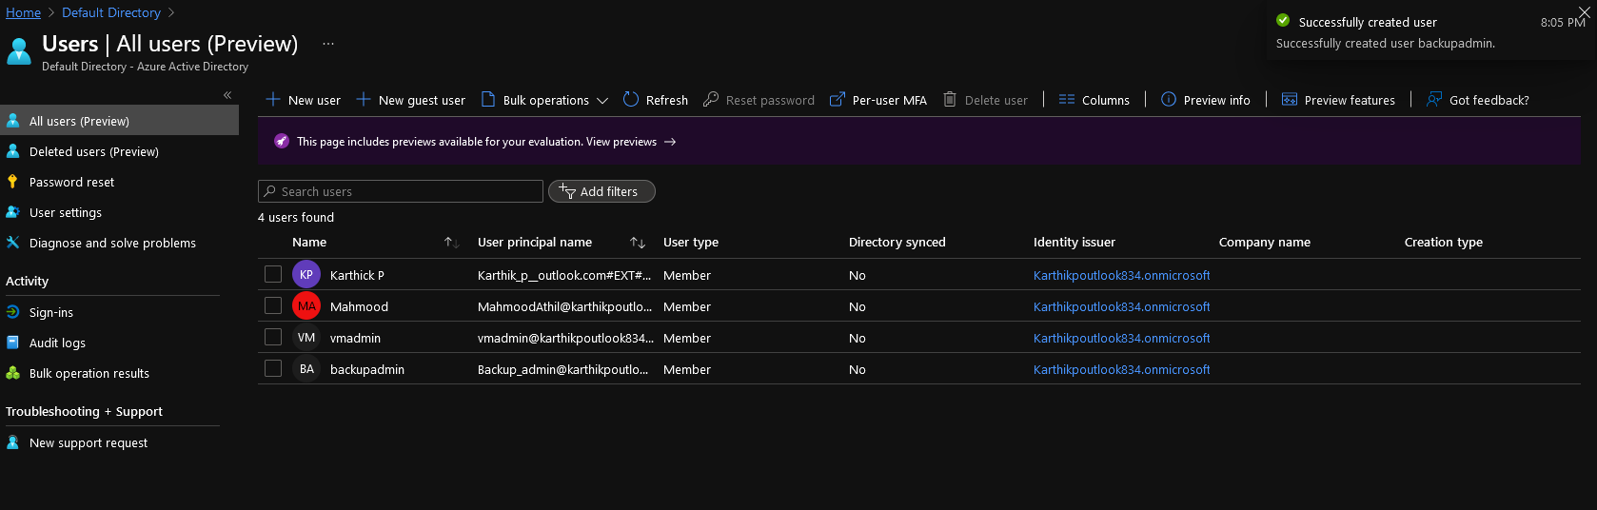

**Adding Vmadmin as Virtual Machine contributor for the subscription:**

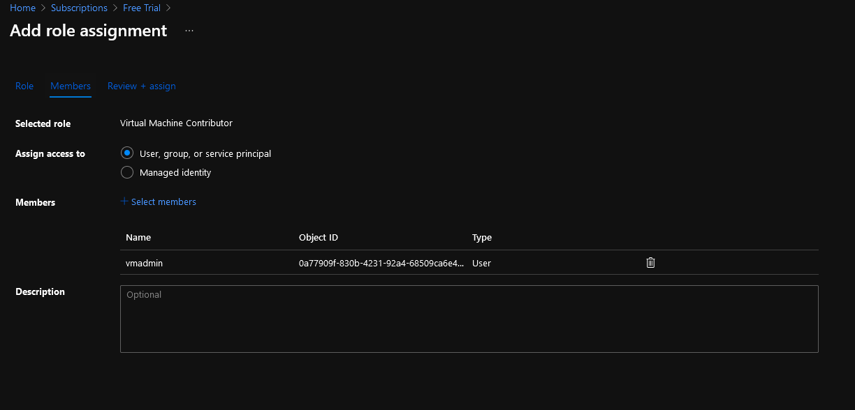

**VM ADMIN added as VM contributor for the Subscription:**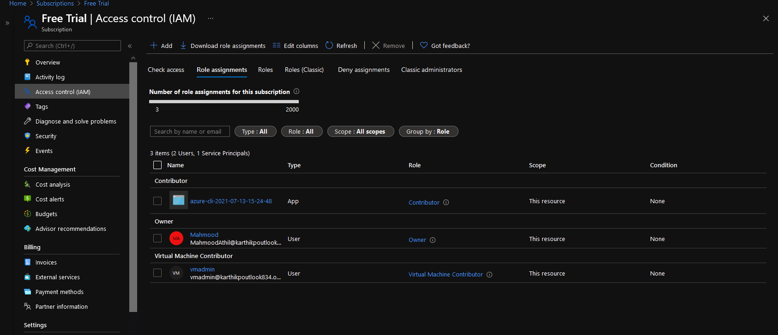

**Backup admin added for Backup in EUS Resource Group:**